what’s inside
The development kit of floatz contains the following folders:

\doc Documentation
\samples Examples
\styles Framework files
\templates Predefined layout templates
\tests Test suite
\tools Tools
The CSS files of floatz resist in the /src folder. They must be imported into your project specific CSS file in the given order:

1> floatz.reset.meyer.css Resets based on Meyer
2> floatz.reset.css floatz specific resets
3> floatz.layout.css Layout elements
4> floatz.form.css Form elements
5> floatz.nav.css Navigation elements

To switch from fixed to fluid or centered layout, the following CSS
file can optionally be added:

6> floatz.layout.liquid.css OR For liquid layout
6> floatz.layout.center.css For centered layout

Download and more information
http://code.google.com/p/floatz
- layout elements
layout container
Basic elements for layouting pages, content as well as forms.

floatz style | HTML | CSS | Refines | Description
flz_page | DIV | id | - | Page element
flz_box | DIV | class | - | Box element
flz_minwidth | DIV | id | - | Special element to provide minwidth support in IE.
flz_minwidthcontent | DIV | id | - | Special element to provide minwidth support in IE
additional styles for layout container
floatz style | HTML | CSS | Refines | description
flz_clear | DIV | class | flz_box | Clears floating of subsequent box elements
flz_relative | DIV | class | flz_box | Marks box element as container for absolute positioned elements
layouter
Layouters provide additional styles that are used to resize boxes. Use layouters always appropriate to the alignment of the corresponding boxes in your design (e.g. flz_l.. for left aligned box, flz_m.. for mid aligned boxes, flz_r.. for right aligned boxes). Layouter combinations should always result in 100% (expect combinations of 66/33 that result in 99%).

floatz style | HTML | CSS | Refines | Description
flz_10, flz_l20, flz_l25, flz_l33, flz_l40, flz_l50,  flz_l60 flz_l66, flz_l75, flz_l80, flz_l90 | DIV | class | flz_box | Layouter for left aligned box elements
flz_m10, flz_m20, flz_m25, flz_m33, flz_m40, flz_m50, flz_m60, flz_m80 | DIV | class | flz_box | Layouter for mid aligned box elements
flz_r10, flz_r20, flz_r33, flz_r40, flz_r50, flz_r60,  flz_r66, flz_r75, flz_r80, flz_r90, flz_r100 | DIV | class | flz_box | Layouter for right aligned box elements
spacer
Spacers are an easy way to provide whitespace to layout containers. By default spacers are using EM based paddings as whitespace.

floatz style | HTML | CSS | Refines | Description
flz_spacer | DIV | class | - | Spacer for single row / single column layout
flz_lspacer,  flz_mspacer,  flz_rspacer | DIV | class | - | Spacer for single row / multi column layout
flz_spacer_mrsc_top, flz_spacer_mrsc_mid, flz_spacer_mrsc_bottom | DIV | class | - | Spacer for multi row / single column layout
flz_lspacer_mrmc_top, flz_mspacer_mrmc_top, flz_rspacer_mrmc_top, flz_lspacer_mrmc_mid, flz_mspacer_mrmc_mid, flz_rspacer_mrmc_mid, flz_lspacer_mrmc_bottom, flz_mspacer_mrmc_bottom, flz_rspacer_mrmc_bottom | DIV | class | - | Spacer for multi row / multi column layout
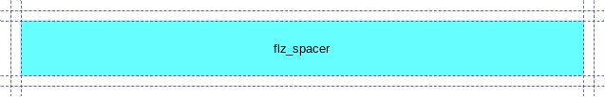
Figure 1 – Spacer in single row, single column scenario
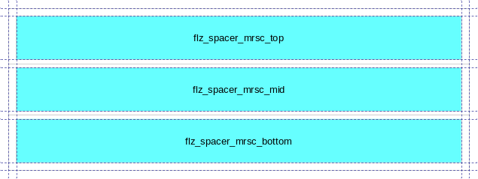
Figure 2 – Spacers in multi row, single column scenario

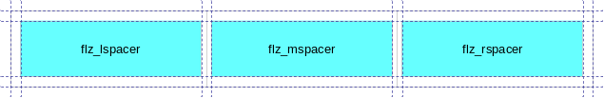
Figure 3 – Spacer in single row, multi column scenario

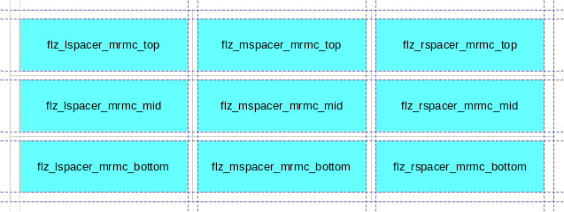
Figure 4 – Spacer in multi row, multi column scenario
subspacer
Subspacers are primarily helpful for complex layouts with nested layout containers. Combined with spacers, almost every imaginable page, content or form layout can be realized.
floatz style | HTML | CSS | Description
flz_subspacer | DIV | class | Subspacer for single row / single column szenario
flz_lsubspacer,  flz_msubspacer,  flz_rsubspacer | DIV | class | Subspacer for single row / multi column layout
flz_subspacer_mrsc_top, flz_subspacer_mrsc_mid, flz_subspacer_mrsc_bottom | DIV | class | Subspacer for multi row / single column layout
flz_lsubspacer_mrmc_top, flz_msubspacer_mrmc_top, flz_rsubspacer_mrmc_top, flz_lsubspacer_mrmc_mid, flz_msubspacer_mrmc_mid, flz_rsubspacer_mrmc_mid, flz_lsubspacer_mrmc_bottom, flz_msubspacer_mrmc_bottom, flz_rsubspacer_mrmc_bottom | DIV | class | Subspacer for multi row / multi column layout

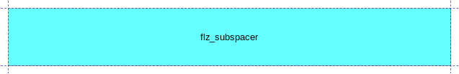
Figure 5 – Subspacer in single row, single column scenario
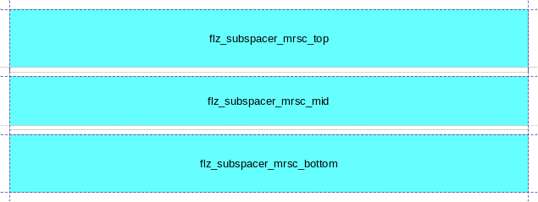
Figure 6 – Subspacer in multi row, single column scenario
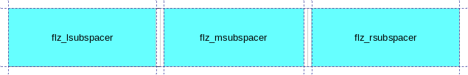
Figure 7 – Subspacer in single row, multi column scenario
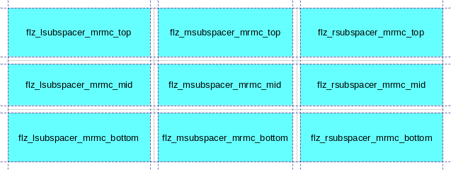
Figure 8 – Subspacer in multi row, multi column scenario
- navigation elements
floatz provides a set of predefined elements to add common navigation scenarios to web applications. All navigation elements are based on unsorted lists.

floatz style | HTML | CSS | Refines | Description
flz_listnav | UL | class | - | Simple list navigation
flz_breadcrumb | UL | class | flz_listnav | Converts a list navigation element to an absolute positioned breadcrumb element
flz_toolbar | UL | class | flz_listnav | Converts a list navigation element to an absolute positioned toolbar element
flz_topnav | UL | class | flz_topnav | Converts a list navigation element to an abolsute positioned top navigation element
flz_hmenu | DIV | class | flz_box | Horizontal menu element
flz_vmenu | DIV | class | flz_box | Vertical menu element
flz_tabmenu | DIV | class | flz_box | Horizontal tabbed menu element
additional styles for navigation elements
floatz style | HTML | CSS | Refines | Short description
flz_selected | A,  LI* | class | - | Marks selected navigation item within a navigation element
*used in tabbed menus
- form elements
floatz ships with a set of predefined form elements that simplify form handling with auto layouting support. In combination with layout containers, layouters, spacers and subspacers also complex form layouts are realizable - without the need for layout tables.

floatz style | HTML | CSS | Refines | Description
flz_blockform | FORM | class | - | Form element provides auto-sizing for contained input elements
flz_button | INPUT | class | - | Button element
flz_checkbox | INPUT | class | - | Checkbox element
flz_radio | INPUT | class | - | Radiobutton element
flz_textbox | INPUT | class | - | Textbox element
additional styles for form elements
floatz style | HTML | CSS | Refines | Description
flz_mandatory | INPUT, SELECT, TEXTAREA | class | flz_button, flz_checkbox, flz_radio, flz_textbox | Marks mandatory input elements
flz_readonly | INPUT, SELECT, TEXTAREA | class | flz_button, flz_checkbox, flz_radio, flz_textbox | Marks readonly input elements
flz_inline | INPUT, SELECT, TEXTAREA | class | flz_checkbox, flz_radio | Converts block form element to inline form element
flz_combifield | DIV,  SPAN | class | - | Special element that supports auto-sizing of combined input fields (e.g. textbox with button)

